

**UNIVERSITI MALAYSIA TERENGGANU**

**___________________________________________________________**

**CSM3023 -PEMBANGUNAN APLIKASI BERASASKAN WEB**

**BANCHELOR OF COMPUTER SCIENCE (MOBILE COMPUTING) WITH HONORS**

**LAB 4 – JSP: Scriplet, Expression and Standard Action**

**SEMESTER 2 2023/2024**

**___________________________________________________________**

**PREPARED FOR:**

DR MOHAMAD NOR BIN HASSAN HASSAN

**PREPARED BY:**

NUR EZREENA SHUHADA BT EMRAN

S66467

**Task 1: Using JSP Scripting**

**Customer.html**

|  |
| --- |
| <!DOCTYPE html>  <!--  Click nbfs://nbhost/SystemFileSystem/Templates/Licenses/license-default.txt to change this license  Click nbfs://nbhost/SystemFileSystem/Templates/JSP_Servlet/Html.html to edit this template  -->  <html>  <head>  <title>Task 1</title>  <meta charset="UTF-8">  <meta name="viewport" content="width=device-width, initial-scale=1.0">  <style>  h2{  color:purple;  }  label{  display: inline-block;  margin-right:10px;  width: 150px;  }  </style>  </head>  <body>  <h1>Use JSP Scriplet and JSP Expression in Application</h1>  <h2> Customer dicount</h2>    <form action="processCustomer.jsp">    <label for="cust_no">Customer code </label>  <input type="text" id="cust_no" name="cust_no" placeholder="key in customer code">  <br><br>  <label for="quantity">Quantity</label>  <input type="number" id="quantity" name="quantity" placeholder="key in quantity">  <br><br>  <label>Customer Type</label>  <input type="radio" id="normal" name="cust_type" value="Normal customer">  <label for="normal">Normal Customer</label>  <input type="radio" id="privilege" name="cust_type" value="Privilege customer">  <label for="privilege">Privilege Customer</label>  <br><br>  <input type="submit" value="Submit">  <input type="reset" value="Cancel">  </form>  </body>  <footer>  &copy;2024 EZREENA  </footer>  </html> |

**proccessCustomer.jsp**

|  |
| --- |
| <%--  Document : processCustomer  Created on : 28 Apr 2024, 11:58:17 pm  Author : Nur Ezreena  --%>  <%@page contentType="text/html" pageEncoding="UTF-8"%>  <!DOCTYPE html>  <html>  <head>  <meta http-equiv="Content-Type" content="text/html; charset=UTF-8">  <title>Task 1</title>  </head>  <body>  <h1>Use JSP Scriplet and JSP Expression in Application</h1>  <%  final int price = 10;    String cust_no1 = request.getParameter("cust_no");  int quantity1 = Integer.parseInt(request.getParameter("quantity"));  String cust_type1 = request.getParameter("cust_type");    if (cust_type1.equals("1") && quantity1 >100){  out.print("You're entitle" + "10%");%> <br> <%  out.print("Total amount is RM" + quantity1 * price *0.9);  } else if (cust_type1.equals("2") && quantity1 >100){  out.print("You're entitle" + "25%");%><br> <%  out.print("Total amount is RM" + quantity1 * price * 0.75);  }else{  out.print("You're not entitle discount..!");%> <br> <%  out.print("Total amount is RM" + quantity1 * price);  }  %>  </body>  <footer>  &copy;2024 EZREENA  </footer>  </html> |

**Output:**

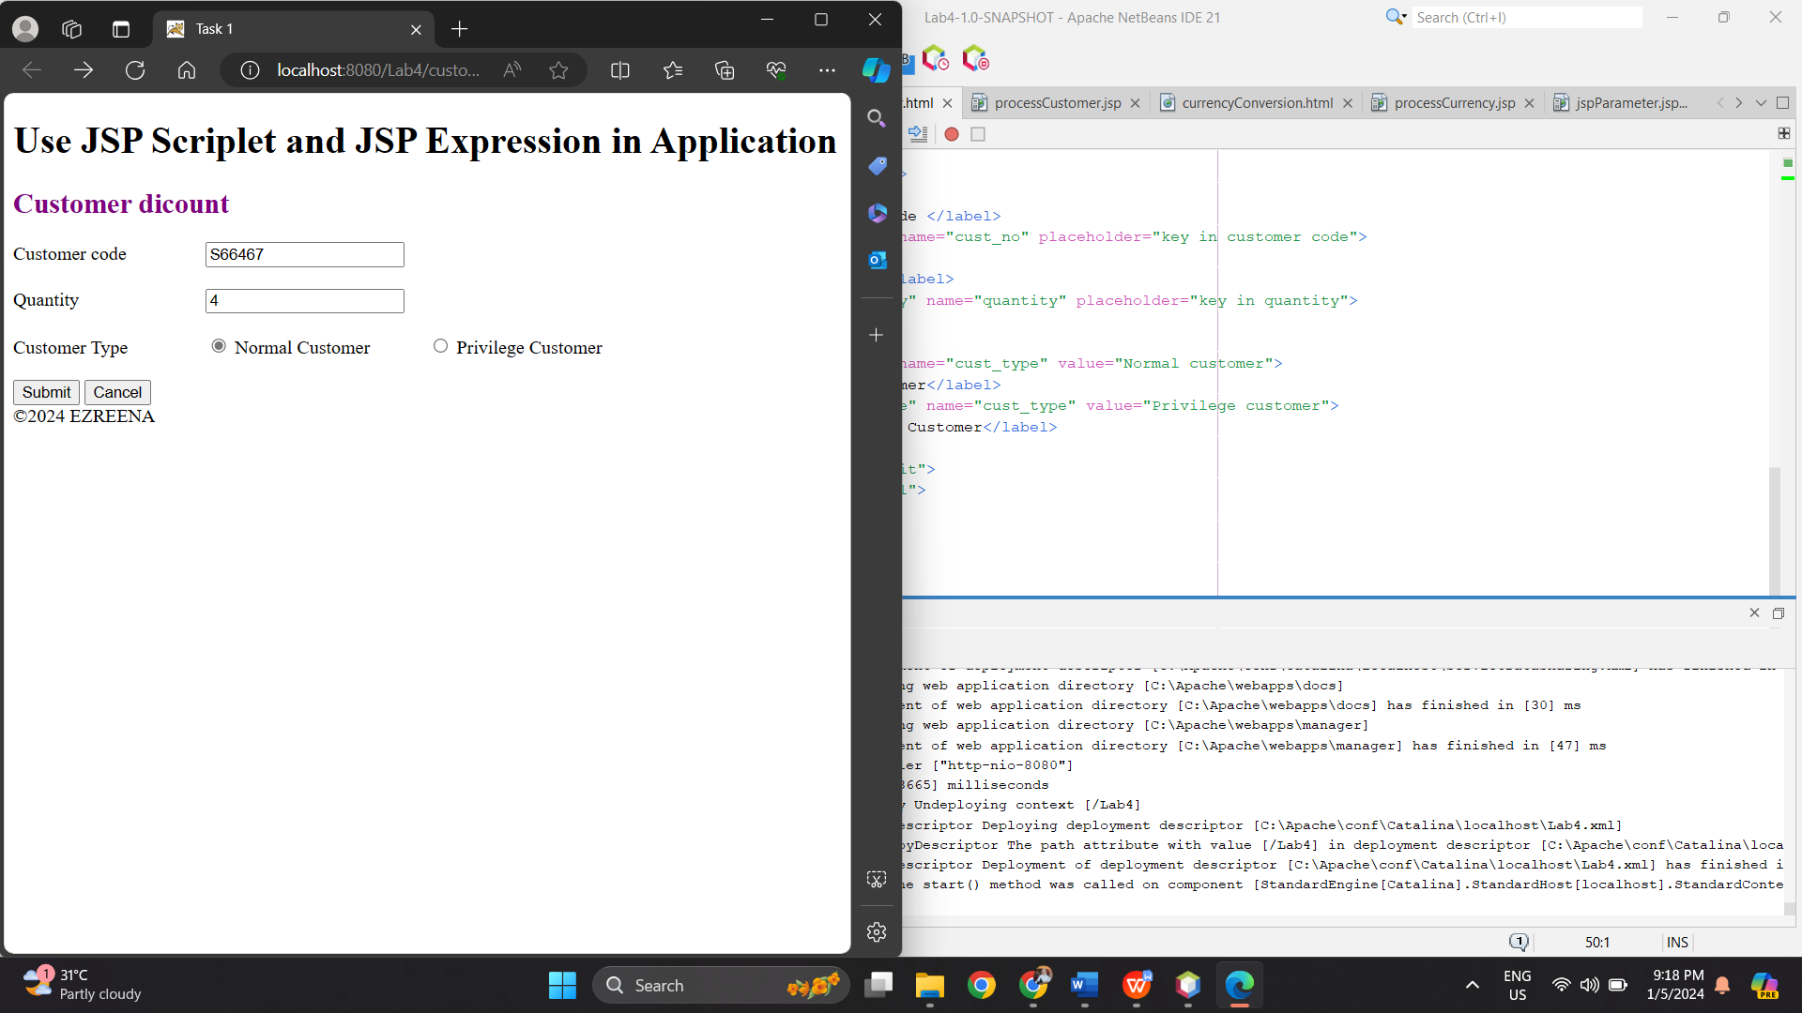

Reflection

1. What you have learnt from this exercise?

This exercise taught me how to use JSP scriptlet and expression to add Java code directly into HTML, handle form data, use conditional statements, and generate dynamic content on web pages.

1. Explain three (3) type of JSP scripting?

* JSP Scriptlet: Embeds Java code directly into the JSP page.
* JSP Expression: Outputs Java expression results into HTML.
* JSP Declaration: Declares global variables and methods in the JSP page.

**Task 2: Using JSP (Scripting, Declaration and Expression)**

**currencyConversion.html**

|  |
| --- |
| <!DOCTYPE html>  <!--  Click nbfs://nbhost/SystemFileSystem/Templates/Licenses/license-default.txt to change this license  Click nbfs://nbhost/SystemFileSystem/Templates/JSP_Servlet/Html.html to edit this template  -->  <html>  <head>  <title>Task 2</title>  <meta charset="UTF-8">  <meta name="viewport" content="width=device-width, initial-scale=1.0">  <style>  h2{  color:purple;  }  label{  display: inline-block;  margin-right:10px;  width: 150px;  }  </style>  </head>  <body>  <h1>Use JSP Scriplet and JSP Expression in Application</h1>  <h2> Currency Conversion</h2>    <form action="processCurrency.jsp" method="post">  <label for="amount">Amount(in RM) :</label>  <input type="number" id="amount" name="amount" placeholder="RM"required><br><br>  <label for="convert">Convert to :</label>  <select id="convert" name="convert" required>  <option value="1">USD</option>  <option value="2">STG</option>  <option value="3">Euro</option>    <button type="submit">Submit</button>  <button ty[e="clear">Cancel</button>  </select><br><br>    <input type="submit" id="btnSubmit" value="Submit"/>  <input type="reset" id="btnCancel" value="Cancel"/>  <br><br>  </body>  <footer>  <br>  &copy;2024 EZREENA  </footer>  </html> |

**processCurrency.jsp**

|  |
| --- |
| <%--  Document : processCurrency  Created on : 29 Apr 2024, 1:05:00 am  Author : Nur Ezreena  --%>  <%@page contentType="text/html" pageEncoding="UTF-8"%>  <!DOCTYPE html>  <html>  <head>  <meta http-equiv="Content-Type" content="text/html; charset=UTF-8">  <title>Currency Conversion</title>  </head>  <body>  <%!  final double USD = 3.92;  final double STG = 5.96;  final double EURO = 4.47;  private double calculateRate(String currency, int amount) {  double currencyChange = 0.00;  if (currency.equals("1"))  currencyChange = (double) (amount / USD);  else if (currency.equals("2"))  currencyChange = (double) (amount / STG);  else if (currency.equals("3"))  currencyChange = (double) (amount / EURO);  return currencyChange;  }  %>  <%  int amount = Integer.parseInt(request.getParameter("amount"));  String convertTo = request.getParameter("convert");  double result = calculateRate(convertTo, amount);  %>    <h1>Use JSP Scriplet and JSP Expression in application</h1>  <p style="color: purple;">Amount in Ringgit Malaysia: RM<%= amount %></p>  <% if (convertTo.equals("1")) { %>  <p style="color: purple;">Amount in US Dollar: <%= String.format("%.2f", result) %></p>  <% } else if (convertTo.equals("2")) { %>  <p style="color: purple;">Amount in British Pound: <%= String.format("%.2f", result) %></p>  <% } else if (convertTo.equals("3")) { %>  <p style="color: purple;">Amount in Euro: <%= String.format("%.2f", result) %></p>  <% } %>  </body>  <footer>  <br><!-- comment -->  &copy;2024 EZREENA  </footer>  </html> |

**Output:**

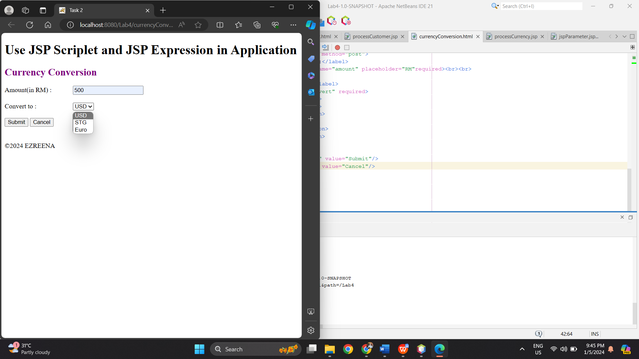

**Task 3: Using JSP Standard Action (Include and Param)**

**jspParam.jsp**

|  |
| --- |
| <%--  Document : jspParameter  Created on : 29 Apr 2024, 11:48:04 pm  Author : Nur Ezreena  --%>  <%@page contentType="text/html" pageEncoding="UTF-8"%>  <!DOCTYPE html>  <html>  <head>  <meta http-equiv="Content-Type" content="text/html; charset=UTF-8">  <title>Using JSP Standard Action</title>  </head>  <body>  <h1>Using JSP : include and jsp :param to display information on JSP page</h1>  <%  String sCode = "CSF3107";  String sSubject = "Web Programming 2";  String sCredit = "3(2+1)";  %>  <jsp:include page = "subjectInfo.jsp" flush = "true">  <jsp:param name = "code" value = "<%=sCode%>"/>  <jsp:param name = "subject" value = "<%=sSubject%>"/>  <jsp:param name = "credit" value = "<%=sCredit%>"/>  </jsp:include>  </body>  <footer>  <br>  &copy;2024 EZREENA  </footer>  </html> |

**subjectInfo.jsp**

|  |
| --- |
| <%--  Document : subjectInfo  Created on : 29 Apr 2024, 11:58:55 pm  Author : Nur Ezreena  --%>  <%@page contentType="text/html" pageEncoding="UTF-8"%>  <!DOCTYPE html>  <html>  <head>  <meta http-equiv="Content-Type" content="text/html; charset=UTF-8">  <title>Using JSP Standard Action</title>  </head>  <body>  <h1>Calling subjectInfo.jsp page</h1>  <p>Code = <%=request.getParameter("code")%></p>  <p>Subject = <%=request.getParameter("subject")%></p>  <p>Credit = <%=request.getParameter("credit")%></p>  </body>  <footer>  <br>  &copy;2024 EZREENA  </footer>  </html> |

**Output:**

Reflection

1. What you have learnt from this exercise?

I learned how to include and send arguments to another JSP page using JSP standard actions like and thanks to this exercise. It also showed how to use Java code to dynamically generate content on a JSP page.

1. List TWO (2) other JSP Standard Action Tag.

* <jsp:forward>: This tag forwards the request from one JSP page to another resource (JSP, HTML, or servlet) on the server. It's typically used for redirecting users to another page.
* <jsp:useBean>: This tag is used to instantiate and access JavaBeans components in a JSP page. It simplifies the process of working with JavaBeans by automatically creating an instance if it doesn't exist.

**Task 4: Using JSP Standard Action (Forward)**

**Forward.jsp**

|  |
| --- |
| <%--  Document : foward  Created on : 30 Apr 2024, 11:28:09 pm  Author : Nur Ezreena  --%>  <%@page contentType="text/html" pageEncoding="UTF-8"%>  <!DOCTYPE html>  <html>  <head>  <meta http-equiv="Content-Type" content="text/html; charset=UTF-8">  <title>Using JSP Standard Action (foward)</title>  </head>  <body>  <h2>Using JSP: foward to display user info.</h2>  <jsp:forward page="fowardInfo.jsp">  <jsp:param name= "U_Name" value="Nur Ezreena"/>  <jsp:param name= "Email" value="ezreena_dudu@gmail.com"/>  <jsp:param name= "Nationality" value="Turkey"/>  <jsp:param name= "Background" value="Developer"/>  </jsp:forward>  </body>  <footer>  <br>  &copy;2024 EZREENA  </footer>  </html> |

**fowardInfo.jsp**

|  |
| --- |
| <%--  Document : fowardInfo  Created on : 30 Apr 2024, 11:42:00 pm  Author : Nur Ezreena  --%>  <%@page contentType="text/html" pageEncoding="UTF-8"%>  <!DOCTYPE html>  <html>  <head>  <meta http-equiv="Content-Type" content="text/html; charset=UTF-8">  <title>&lt;Forwarded_Action Example in JSP&gt;</title>  </head>  <body>  <% String name = request.getParameter("U_Name"); %>  <% String Email = request.getParameter("Email"); %>  <% String Nationality = request.getParameter("Nationality"); %>  <% String Background = request.getParameter("Background"); %>  <% if (name !=null) {%>  <b><br><br><h2 align="center">  <%=name%><br><!-- comment -->  <%=Email%><br><!-- comment -->  <%=Nationality%><br><!-- comment -->  <%=Background%><br><!-- comment -->    <%out.print("Today is:" + java.util.Calendar.getInstance().getTime());%>    </h2></b></br>  <%}%>    </body>  <footer>  <br>  &copy;2024 EZREENA  </footer>  </html> |

**Output:**

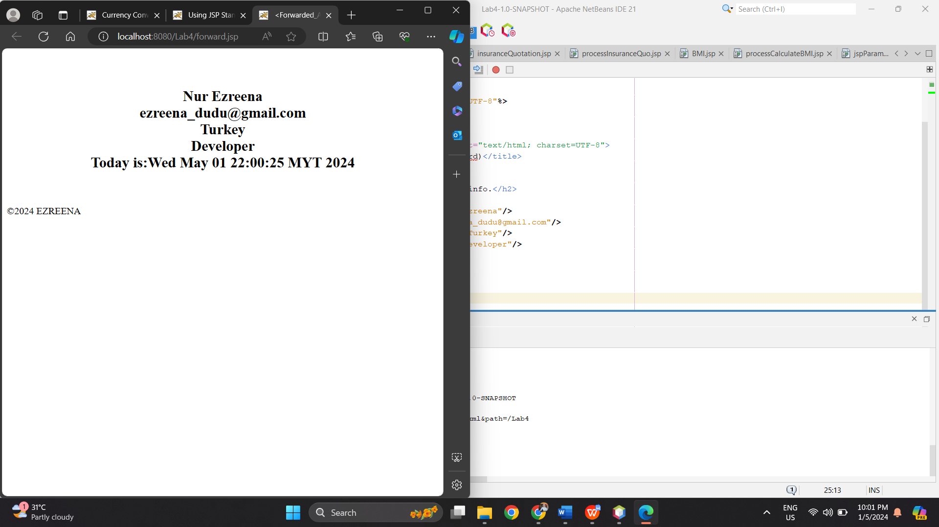

Reflection

1. What you have learnt from this exercise?

Through this exercise, I was able to give arguments and learn how to use the JSP standard action <jsp:forward> to redirect user requests between JSP pages. This supports the separation of concerns in web applications and the modularization of code.

1. List TWO(2) More JSP Standard Action Tag.

* <jsp:useBean>: This tag is used to instantiate and access JavaBeans components in a JSP page. It simplifies the process of working with JavaBeans by automatically creating an instance if it doesn't exist.
* <jsp:setProperty>: This tag is used to set properties of a JavaBean component in a JSP page. It allows you to assign values to bean properties, either through explicit values or by retrieving them from request parameters.

**Task 5: Use Java Scriptlet To Construct Business Logic**

**insuranceQuatation.jsp**

|  |
| --- |
| <%--  Document : insuranceQuotation  Created on : 1 May 2024, 1:19:52 am  Author : Nur Ezreena  --%>  <%@page contentType="text/html" pageEncoding="UTF-8"%>  <!DOCTYPE html>  <html>  <head>  <meta http-equiv="Content-Type" content="text/html; charset=UTF-8">  <title>Task 5</title>  <script>  function validateForm() {  let icno = document.getElementById("icno").value;  let name = document.getElementById("name").value;  let price = document.getElementById("price").value;  if(icno === "" || name === "" || price === "") {  alert("Please fill in all fields");  return false;  }  return true;  }  </script>  </head>  <body>  <h1>Insurance Quotation</h1>  <form action="processInsuranceQuo.jsp" onSubmit="return validateForm()">  <fieldset>  <legend> Insurance Calculation</legend>    <label for="icno">IC No </label>  <input type="text" id="icno" name="icno" placeholder="E.g 124578-08-0564">  <br><br>  <label for="name">Name</label>  <input type="text" id="name" name="name" placeholder="Enter name">  <br><br>  <label for="price">Market Price</label>  <input type="text" id="price" name="price" placeholder="price">  <br><br>    <label for="type">Coverage Type :</label>  <select id="type" name="type" required>  <option value="1">Third Party</option>  <option value="2">Comprehensive</option>  </select><br><br>    <label for="disc">No claims discount (NCD)</label>  <select id="disc" name="disc" required>  <option value="1">10%</option>  <option value="2">25%</option>  <option value="2">35%</option>  <option value="2">55%</option>  </select><br><br>    <button type="submit">Submit</button>  <button type="reset">Cancel</button>    </fieldset>  </form>    </body>  <footer>  &copy 2024-EZREENA  </footer>  </html> |

**proccessInsuranceQuo.jsp**

|  |
| --- |
| <%--  Document : processInsuranceQuo  Created on : 1 May 2024, 1:20:52 am  Author : Nur Ezreena  --%>  <%@page contentType="text/html" pageEncoding="UTF-8"%>  <!DOCTYPE html>  <html>  <head>  <meta http-equiv="Content-Type" content="text/html; charset=UTF-8">  <title>Task 5</title>  </head>  <body>  <%  String icNo = request.getParameter("icno");  String customerName = request.getParameter("name");  double marketPrice = Double.parseDouble(request.getParameter("price"));  String coverageType = request.getParameter("type");  int ncd = Integer.parseInt(request.getParameter("disc"));  double discount = 0.0;    switch (ncd) {  case 1:  discount = 0.1;  break;  case 2:  discount = 0.25;  break;  case 3:  discount = 0.35;  break;  case 4:  discount = 0.55;  break;  }    double totalAmount = marketPrice * (1 - discount);  double gst = totalAmount * 0.06;  double finalAmount = totalAmount + gst;  %>    <fieldset>  <legend><h3>Details of Insurance Quotation</h3></legend>  <p style="color: #7D0DC3;">IC No: <%= icNo %></p>  <p style="color: #7D0DC3;">Customer Name: <%= customerName %></p>  <p style="color: #7D0DC3;">Market Price: RM <%= marketPrice %></p>  <p style="color: #7D0DC3;">Coverage Type: <%= (coverageType.equals("1")) ? "Comprehensive" : "Third-party" %></p>  <p style="color: #7D0DC3;">No Claim Discount (NCD): <%= (discount * 100) %>%</p>  <p style="color: #7D0DC3;">Insurance Amount: RM <%= totalAmount %></p>  <p style="color: #7D0DC3;">6% GST: RM <%= gst %></p>  <p style="color: #7D0DC3;"><strong>Final Amount (with 6% GST): RM <%=  finalAmount %></strong></p>  </fieldset>  </body>  <footer>  <br>  &copy2024 - EZREENA  </footer>  </html |

**Output:**

Reflection

1. What you have learnt from this exercise?

I learned how to use JavaServer Pages (JSP) to develop a basic insurance quotation form with this assignment. It strengthened my knowledge of form data management, server-side scriptlet processing, and JSP syntax. It also showed how to use JavaScript for client-side form validation.

1. List all Java features you used in Java Scriptlet.

* Variable declaration and initialization (String icNo = request.getParameter("icno");)
* Type conversion (Double.parseDouble(request.getParameter("price"));, Integer.parseInt(request.getParameter("disc"));)
* Control flow using switch-case (switch (ncd) { case 1: ...})
* Arithmetic operations (double totalAmount = marketPrice * (1 - discount);)
* String concatenation (<%= (discount * 100) %>%)
* Conditional operator (<%= (coverageType.equals("1")) ? "Comprehensive" : "Third-party" %>)

**Exercise**

**BMI.jsp**

|  |
| --- |
| <%--  Document : BMI  Created on : 1 May 2024, 2:55:32 am  Author : Nur Ezreena  --%>  <%@page contentType="text/html" pageEncoding="UTF-8"%>  <!DOCTYPE html>  <html>  <head>  <meta http-equiv="Content-Type" content="text/html; charset=UTF-8">  <title>BMI </title>  </head>  <body>  <h1>The Body Max Index (UMT)</h1>  <form action="processCalculateBMI.jsp" onSubmit="return validateForm()">  <fieldset>  <legend>Calculate Your BMI</legend>    <label for="weight">Weight in (Kg)</label>  <input type="text" id="weight" name="weight" placeholder="Enter your weight ">  <br><br>    <label for="height">Height in (m)</label>  <input type="text" id="height" name="height" placeholder="Enter your height ">  <br><br>    <button type="submit">Calculate</button>  <button type="reset">Reset</button>  </fieldset>  </body>  <footer>  &copy 2024- EZREENA  </footer>  </html> |

**processCalculateBMI.jsp**

|  |
| --- |
| <%--  Document : processCalculateBMI  Created on : 1 May 2024, 3:21:02 am  Author : Nur Ezreena  --%>  <%@page contentType="text/html" pageEncoding="UTF-8"%>  <%@ page import="java.text.DecimalFormat" %>  <!DOCTYPE html>  <html>  <head>  <meta http-equiv="Content-Type" content="text/html; charset=UTF-8">  <title>Result BMI</title>  </head>  <body>  <h1>BMI calculator - Result</h1>  <%  double weight = Double.parseDouble(request.getParameter("weight"));  double height = Double.parseDouble(request.getParameter("height"));  double bmi = weight / (height * height);  String bmiCategory;    if (bmi < 18.5) {  bmiCategory = "UNDERWEIGHT";  } else if (bmi >= 18.5 && bmi <= 25) {  bmiCategory = "OPTIMAL WEIGHT";  } else {  bmiCategory = "OBESITY";  }  DecimalFormat df = new DecimalFormat("#.##");  String bmiFormatted = df.format(bmi);  %>    <p>For the information you entered:</p>  <p> Weight : <%= weight %></p>  <p> Height : <%= height %></p>  <p style="color: blue;" >Your BMI is <%= bmiFormatted %></p>  <p style="color: blue;" >You are <%= bmiCategory %>.</p>  </body>  </html> |

**Output:**

